MEMORIAL HALL
Technical Specifications
1225 Elm St, Cincinnati, OH 45202 · memorialhallotr.com · Virtual tour: memorialhallotr.com/virtual-tour
DIRECTOR OF MEMORIAL HALL  Joshua Steele  JSteele@3cdc.org | SENIOR PRODUCTION SUPERVISOR  Brian Lloyd  BLloyd@3cdc.org

AT A GLANCE
Capacity | 556 seats: 215 on the main level (orchestra) and 341 in the balcony. All 11 accessible seats are on the main level.
Stage | Trapezoidal, 37'4" at the widest point and 22'5" deep at center. Permanent orchestra shell; no soft goods and no overstage rigging.
Load-in | Street-level door on Grant Street (2'7" W × 6'10" H) into a freight elevator. No dock. The stage is on the second floor.
Power | One 400A 3-phase disconnect, backstage stage right. No shore power; generators are OK.
House console | DiGiCo Quantum 225 with Pulse and a DQ Stage rack (48 inputs), in the house right balcony.
PA | Sound Bridge line array (main and balcony hangs, L/R), dual 18" subs and 4 front fills.
Monitors | 8 wedges and 4 in-ear systems, mixed from FOH. A Yamaha CL3 monitor console and split are available; a fee may apply.
Lighting | ETC Ion Element 40 running an LED rep rig with Source 4s, 8 moving heads and 4 truss towers.
Video | 10,000-lumen laser projector and a 20' motorized 16:9 screen, fed by HDMI from backstage.
Sound limit | 95 dB LAeq,6min (A-weighted, 6-minute average) at balcony center, per local ordinance.
Building curfew | 90 minutes after the scheduled end of the show. All touring personnel, artists and gear must be out of the building by then.

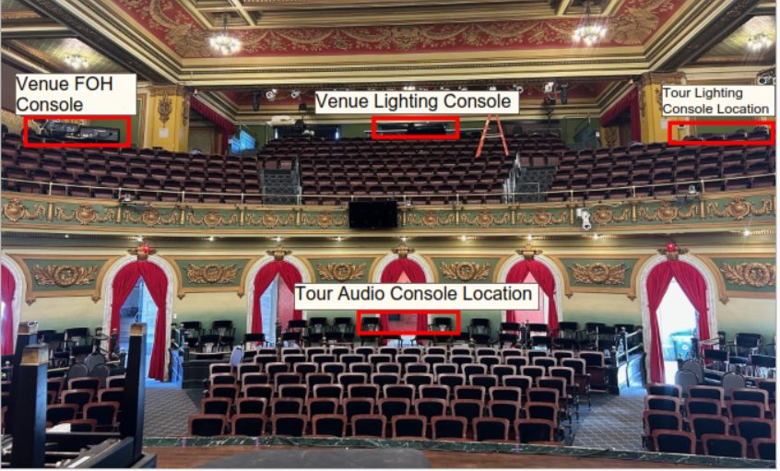
The room from the stage, with the house FOH, house lighting, touring lighting and touring FOH positions marked

STAGE
Shape | Trapezoidal.
Width | 22'5" at the back wall; 37'4" at the widest point.
Depth | 22'5" at the deepest point (center stage).
Height | 11'5" at the back-wall ledge; 18' at center stage; 23' at downstage center.
Shell | Permanent orchestra shell. The ornate upstage wall is 12' high and scallops to 20'+ at the plaster line.
Rigging | No soft goods. No overstage rigging for backdrops, soft goods or lighting.
Entrances | Stage left and stage right doorways, 2'7" W × 6'10" H.  A 5'11" piano door on the upstage right wall for load-in.
House to stage | Steps from the house to the stage, with or without a railing, can be added in the aisles.
Building | Opened 1908. Listed on the National Register of Historic Places in 1978.

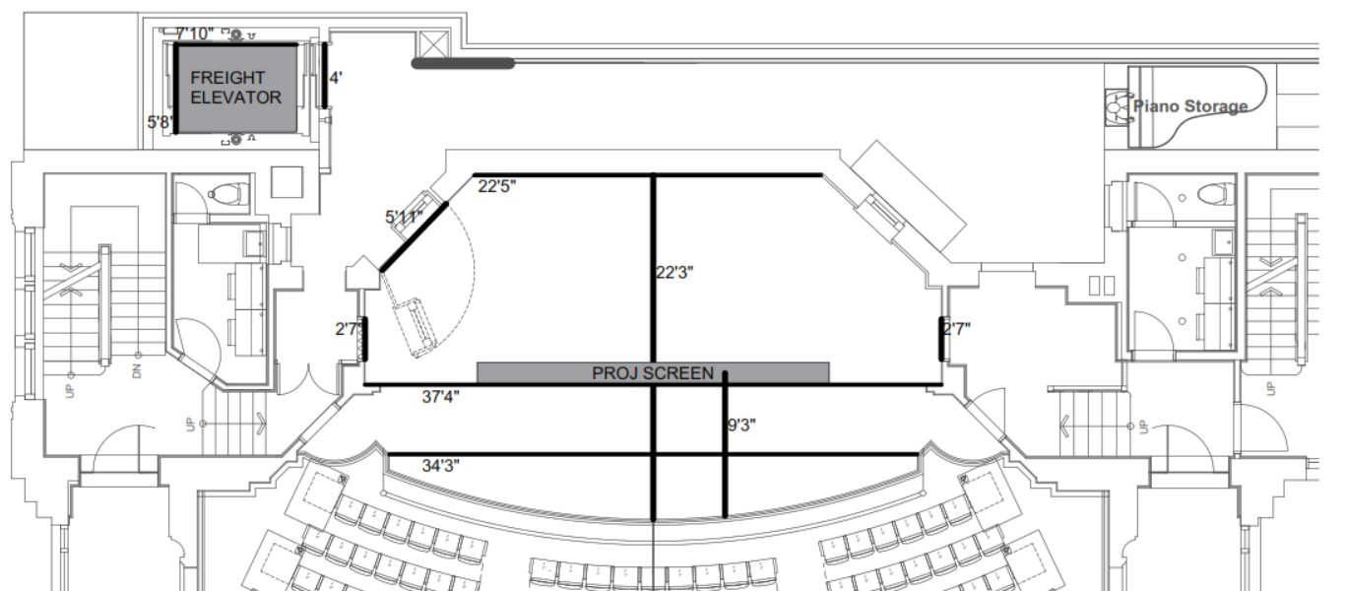
Stage plan with dimensions

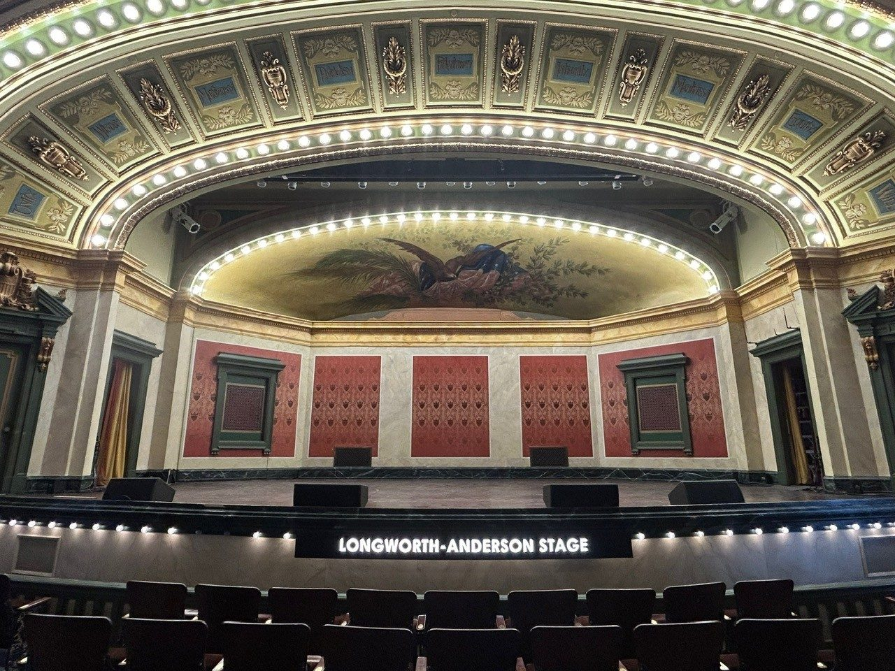  The stage from the orchestra | 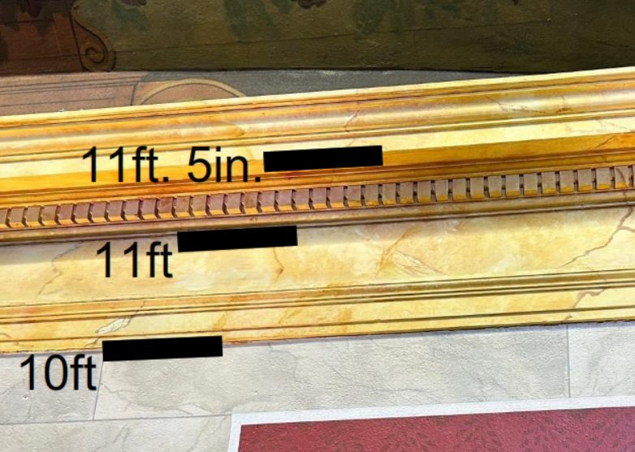  Trim and ledge heights on the upstage wall

LOAD-IN, PARKING & POWER
Loading door | On Grant Street at street level. Standard doorway, 2'7" W × 6'10" H. Flat push; no loading dock.
Freight elevator | Just inside the loading door. 5' W × 7'8" L × 7' H.
Stage level | The stage is on the second floor.
Parking | Details come with your advance.
Power | One 400A 3-phase disconnect, backstage stage right.
Shore power | None. Generators are OK.

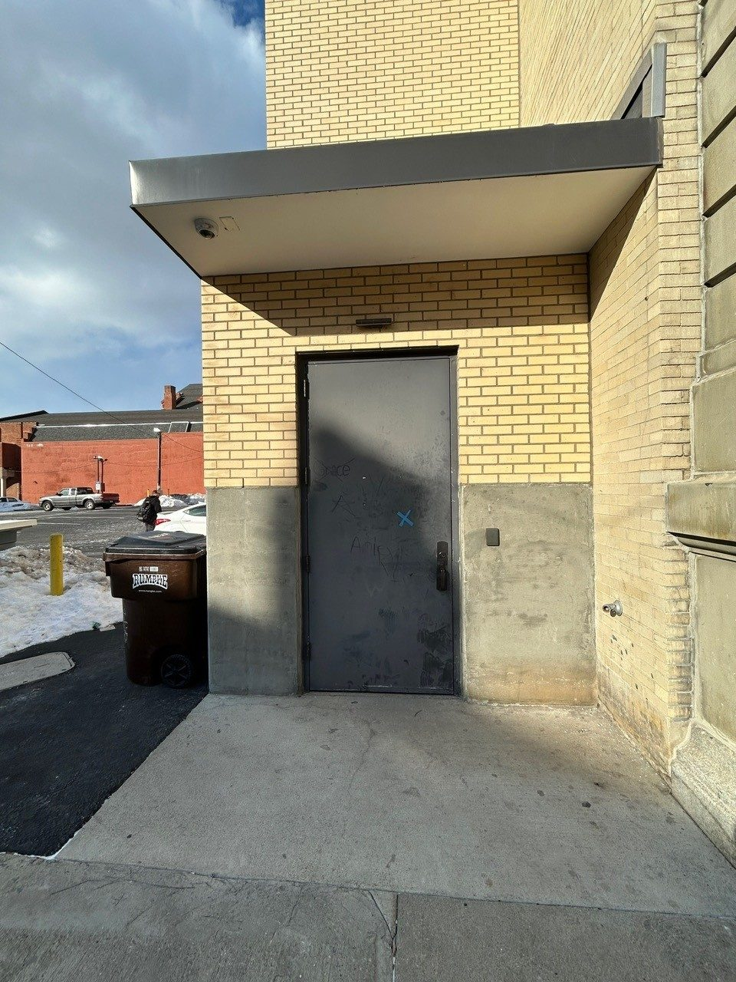  Loading door on Grant Street | 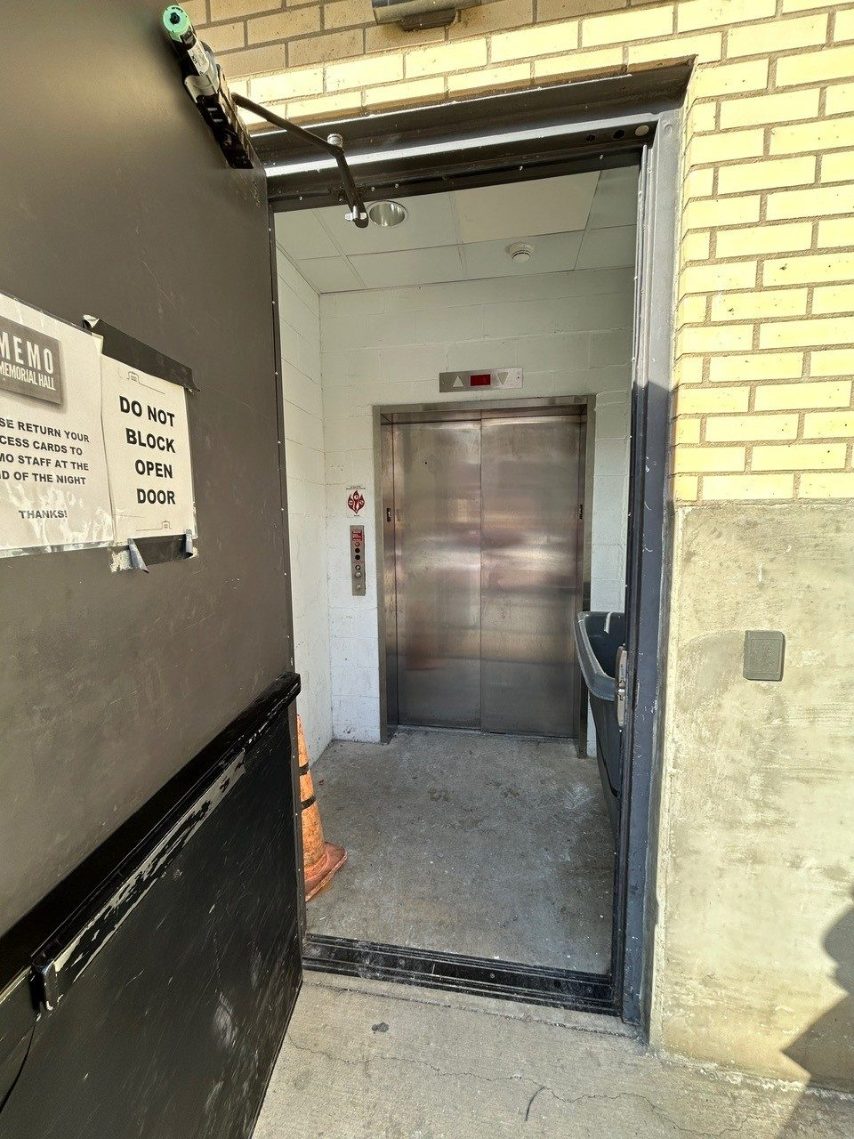  Freight elevator, just inside the loading door | 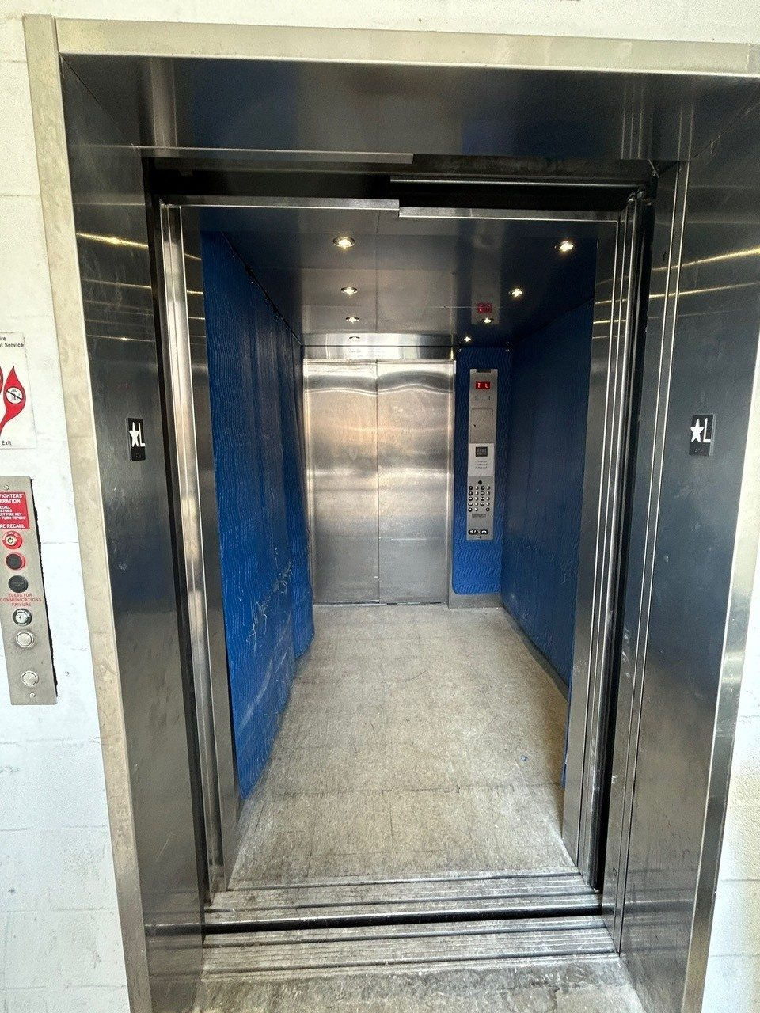  Inside the freight elevator

AUDIO

PA SYSTEM
QTY | MODEL | POSITION
3 per hang | Sound Bridge Xyon 7108XY line array | Main and balcony hangs, L/R
2 per side | Sound Bridge 7218SWX dual 18" subwoofer | Ground-stacked, L/R
4 | Sound Bridge 3208HTH front fill | Mono

FRONT OF HOUSE
House console | DiGiCo Quantum 225 with Pulse.
Stage rack | DiGiCo DQ Stage rack, 48 inputs.
Position | House right balcony, with a full view of the stage and no booth or overhang. The house console is in a fixed position and does not move.

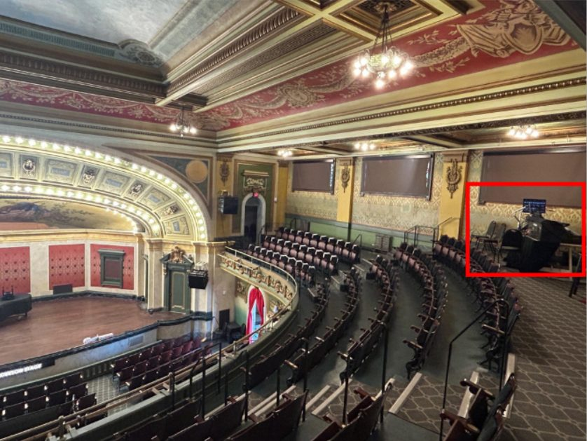  House FOH position, house right balcony (red box) | 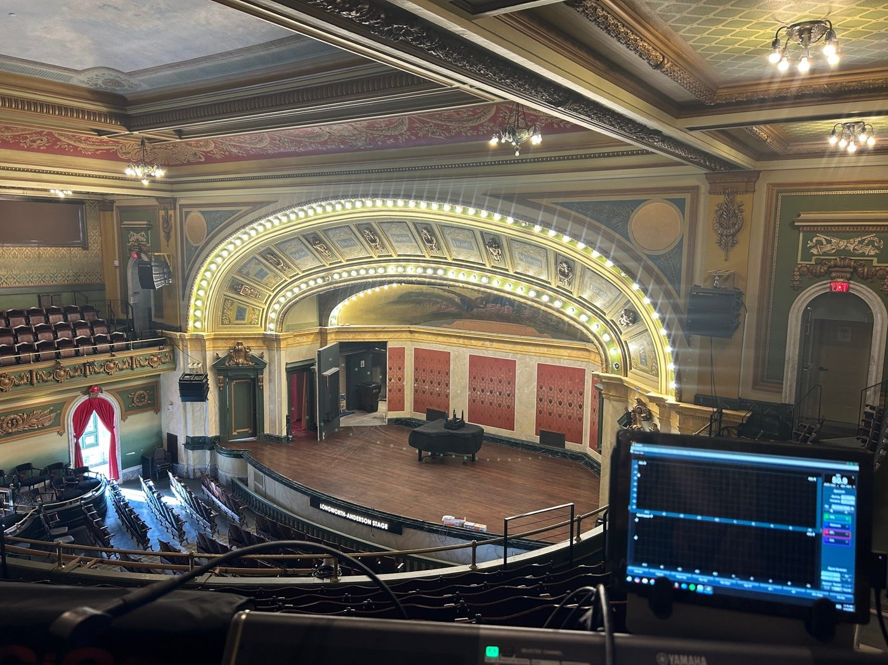  View from the house FOH console

TOURING FOH
Routing | Guest consoles run through the house console. We can accept left, right, sub, fill and assisted listening feeds, or any combination of them.
Position | Rear center of the orchestra (Box M), with a full view of the stage and no booth or overhang.
Cabling | No drylines at this position; PA drivelines are stage left. The run to the stage box is about 150'. Tours must bring all cables needed to connect the touring console to any stage racks or devices.

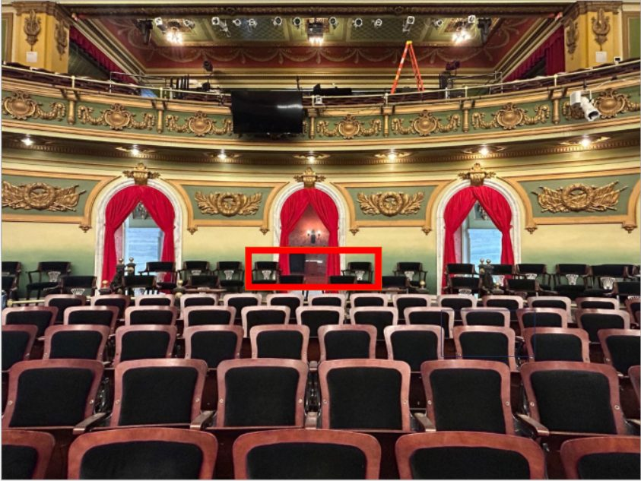  Touring FOH position, Box M (red box) | 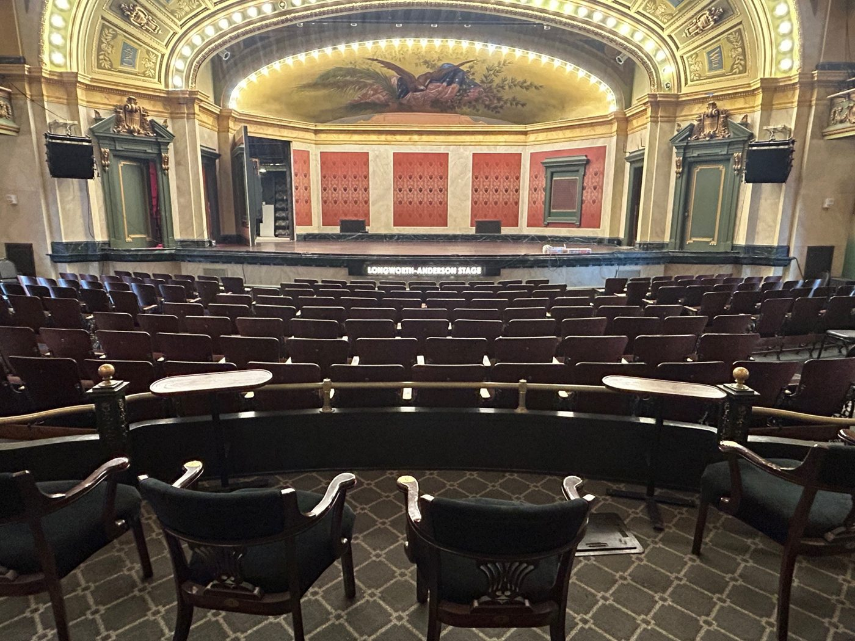  View from the touring FOH position

MONITORS
Wedges | 8 Sound Bridge 7122W 12" stage monitors.
In-ears | 4 Sennheiser EW300 in-ear systems.
Monitor mixes | Run from FOH on the house console unless a monitor console is in use.
Monitor console | Yamaha CL3, 48 inputs. A fee may apply.
Split | 40-channel transformer-isolated split. It's required when using the house monitor console, and it can also feed a touring monitor console. A fee may apply.
Monitor position | Offstage left, through a 2'7" W × 6'10" H doorway.

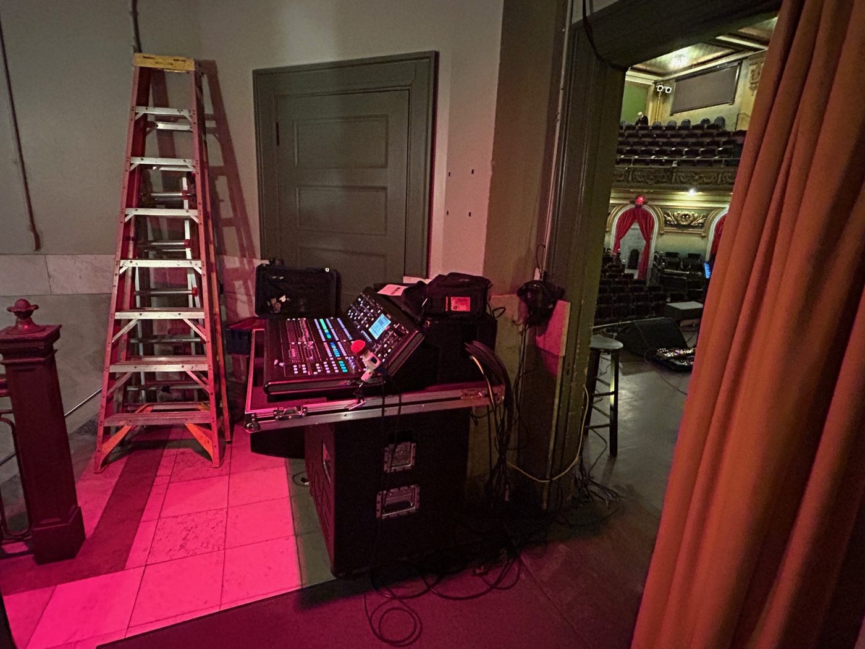  Monitor position, offstage left | 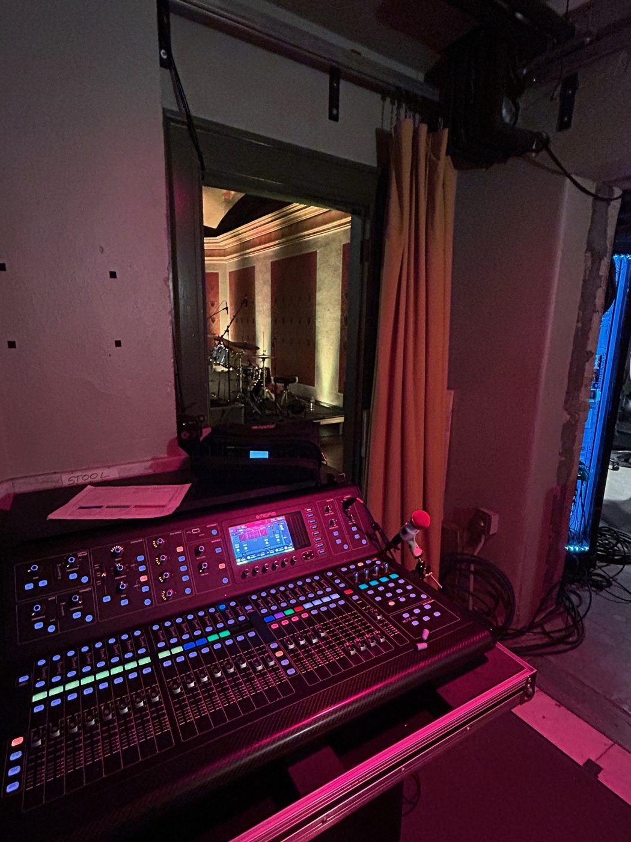  View from the monitor position

SOUND LEVEL LIMIT
Local ordinance limits Memorial Hall to 95 dB LAeq,6min: the A-weighted equivalent level averaged over 6 minutes, measured at balcony center.

RECORDING & ARCHIVING
We offer recording and archiving packages. Package options are available on request.

MICROPHONES & DI
QTY | MODEL | TYPE | NOTE
8 | Shure SM58 | Dynamic, vocal
8 | Shure SM57 | Dynamic, instrument
1 | Shure Beta 57A | Dynamic, instrument
1 | Shure Beta 52A | Dynamic, kick
1 | Shure Beta 91A | Boundary, kick
2 | Sennheiser e609 | Dynamic, guitar cab
4 | Sennheiser e604 | Dynamic, drum clip
2 | Shure SM81 | Small-diaphragm condenser
2 | Shure Beta 27 | Large-diaphragm condenser
2 | AKG C414 | Large-diaphragm condenser
2 | Telefunken M60 | Small-diaphragm condenser
4 | Shure ULX-D2 / Beta 58A | Wireless handheld
2 | Shure SLX / SM58 | Wireless handheld
3 | Lavalier mic | Lavalier | May incur a fee
5 | Countryman E6 | Headset | May incur a fee
10 | Radial JDI | Passive DI

Specific mic requests are possible with advance notice, but additional fees may apply.

LIGHTING
House console | ETC Ion Element 40, at the rear of the upper balcony, center.
House lights | Our console and crew always run the house lights.
Tour console | Touring lighting consoles go in the house left balcony.
Ground package | Tours bringing a ground package must supply 150' of cable to reach it.
Paperwork | The house rep plot and other lighting paperwork are available on request.

INVENTORY
QTY | FIXTURE | NOTE
14 | ETC Source 4, 14° and 19°
10 | ETC Lustre LED, zoom
2 | Robin DLX moving head
6 | LED wash/zoom moving head, 36 × 18W
14 | LED overhead track wash
8 | LED uplight
4 | Elation Fuze 120 LED wash
2 | 1 × 1 × 5 stand-alone truss, 4 LED flat pars each | Mounted
2 | 1 × 1 × 8 stand-alone truss, 4 LED flat pars each | Mounted
1 | Radiant water-based hazer | Additional fee
2 | Spotlight | Additional fee

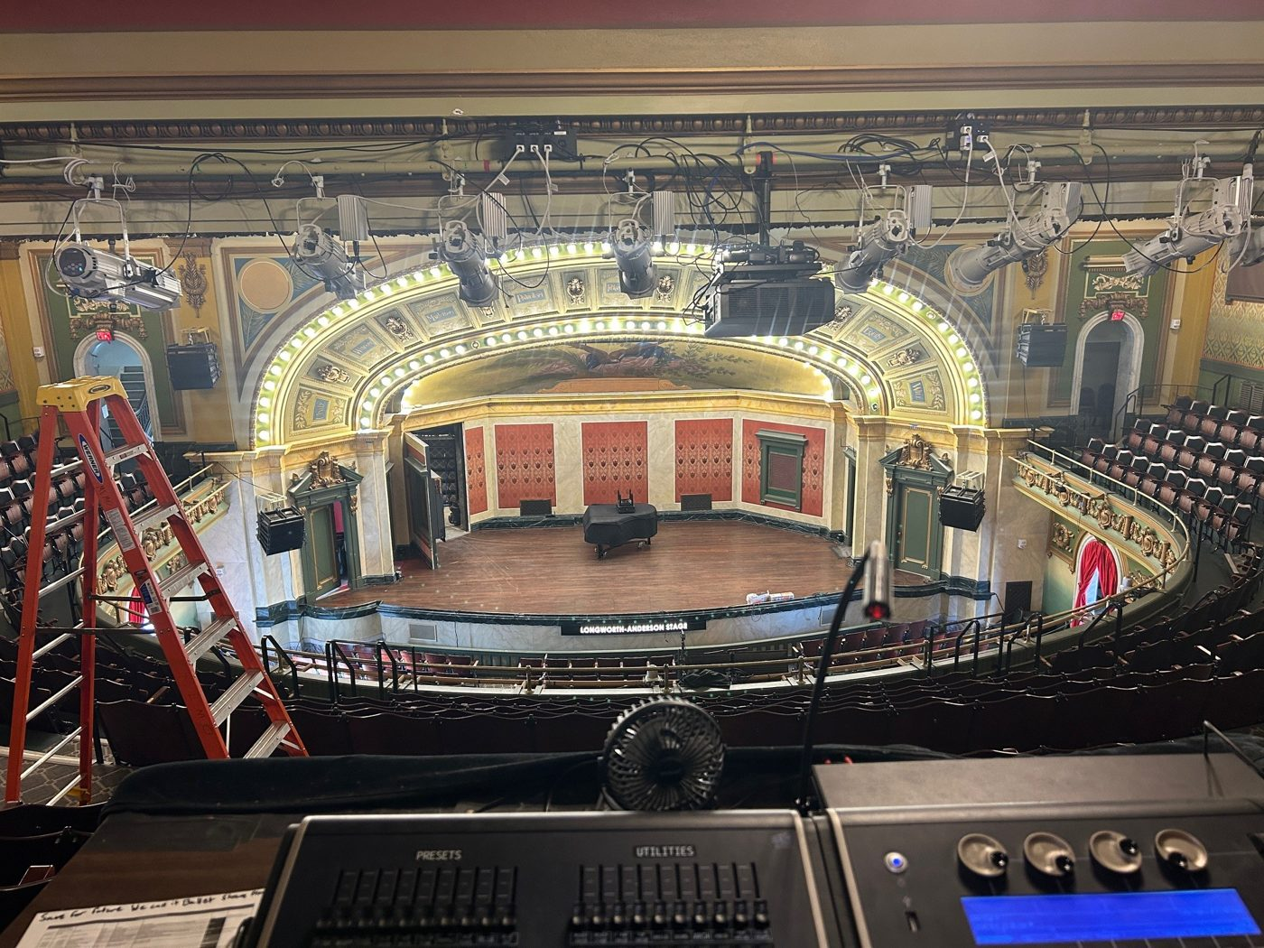  View from the house lighting console | 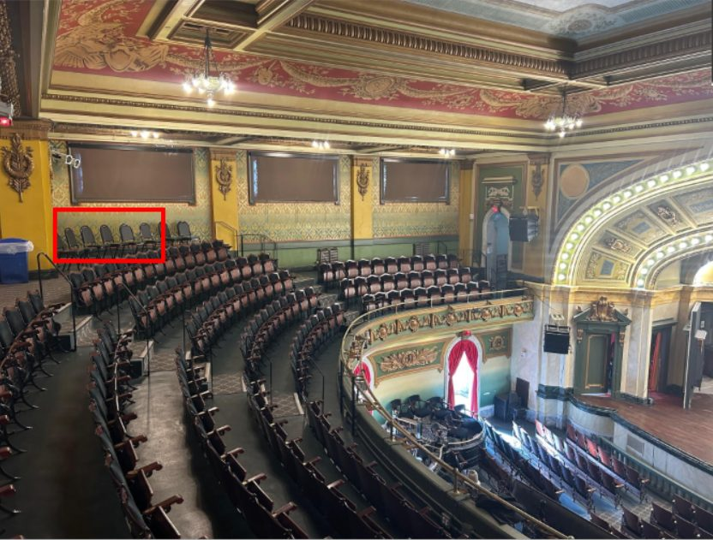  Touring lighting position in the house left balcony (red box), shot from house right | 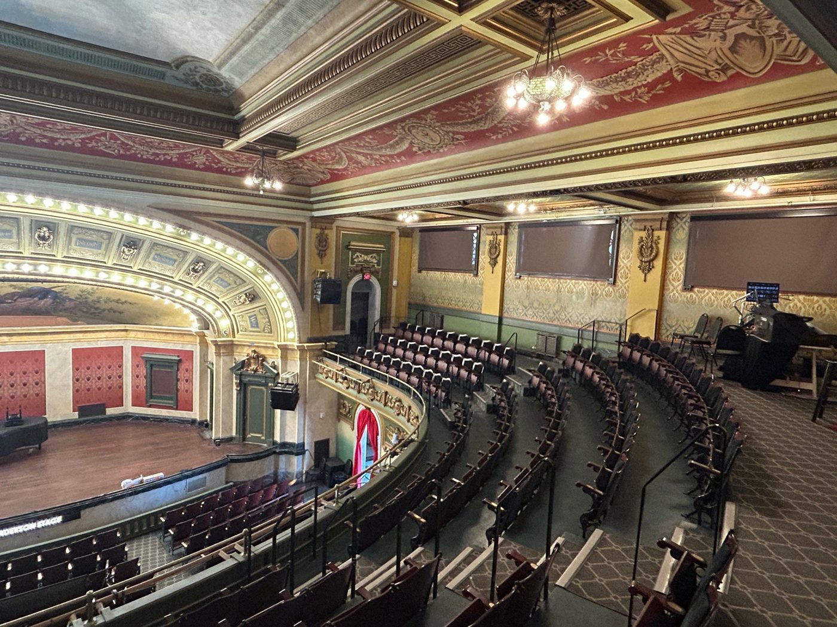  View from the touring lighting position

VIDEO
Projector | Panasonic PT-RZ970BU laser projector, 10,000 lumens, WUXGA.
Screen | 20' motorized screen, 135" × 240", 16:9. It can be partly lowered, with the picture resized to fit.
Position | About 13' from the back wall and 9' upstage of the lip. The screen can't be rehung.
Input | HDMI from backstage.

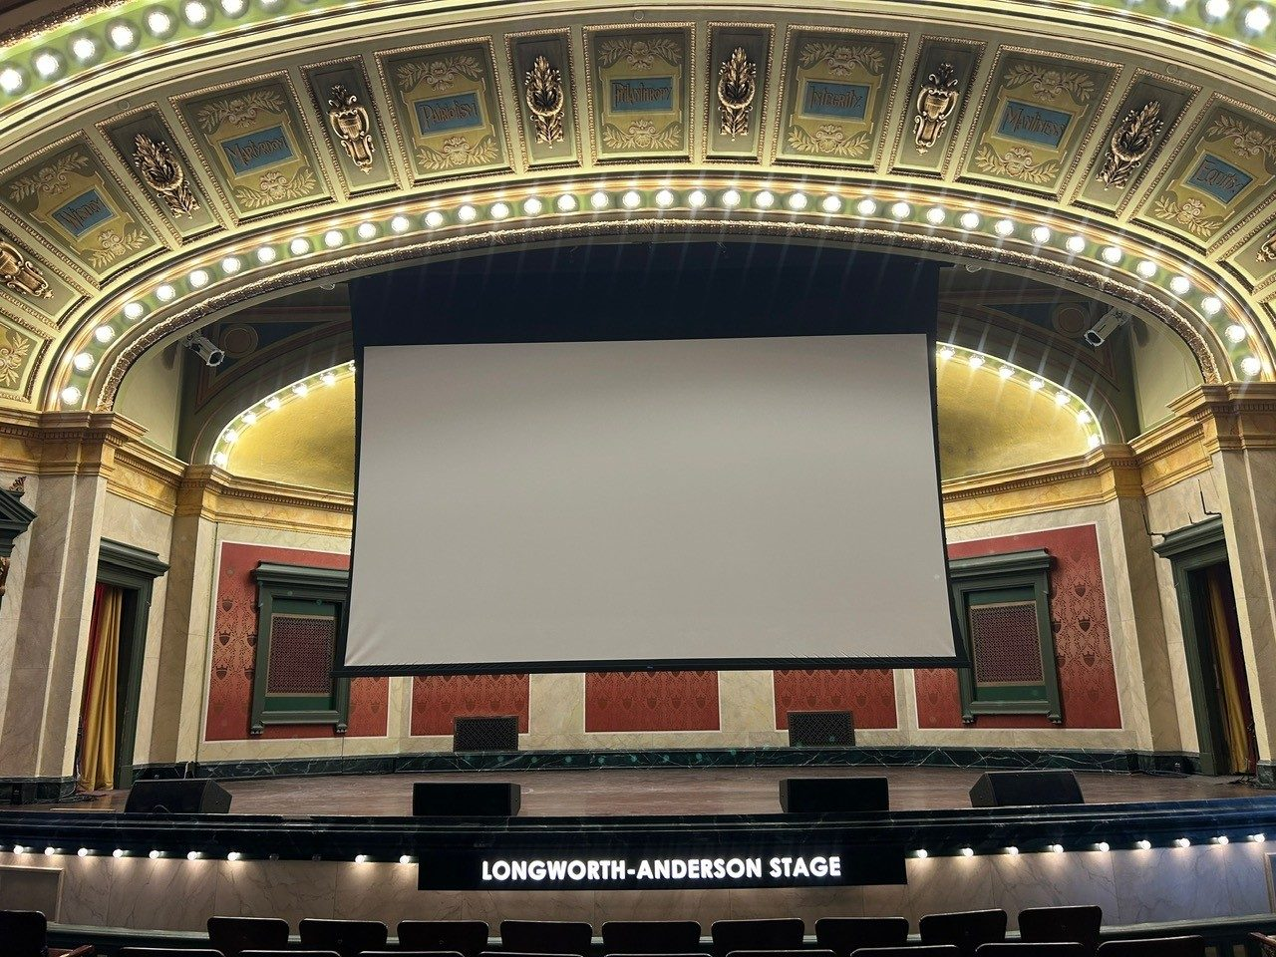  The screen fully lowered, seen from the orchestra | 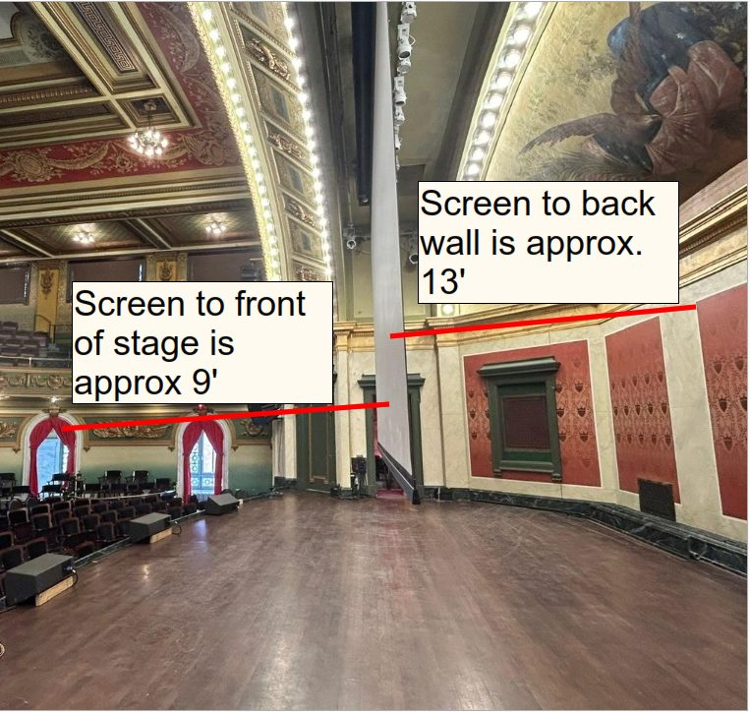  The screen from backstage, stage left

BACKLINE & STAGE EQUIPMENT
The house has no backline instruments or amps, but we can arrange backline rentals.

PIANO
Yamaha C3 PE grand (6'1") with Helpinstill pickups.

STANDS & SEATING
QTY | ITEM | NOTE
10 | Tall tripod boom stand
2 | Medium tripod boom stand
6 | Short tripod boom stand
2 | Tall round-base boom stand
5 | Tall round-base straight stand
4 | Short tabletop mic stand
11 | Guitar stand
25 | Music stand
1 | Conductor's music stand
25 | Clip light | May incur a fee
20 | Wenger orchestra chair
6 | Backless barstool, unpadded

RISERS & STAGING
QTY | ITEM | NOTE
4 | Wenger riser, 4' × 8' × 12" | Black skirting
6 | Wenger 3-level choral riser
1 | Conductor's podium
 | Pipe and drape | Covers the back wall of the stage
1 | Large wooden podium | Gooseneck mic
1 | Small black podium | Gooseneck mic
 | Drum rugs

DRESSING ROOMS & AMENITIES
Five dressing rooms, all lockable and climate-controlled.
ROOM | LEVEL | CAPACITY | FEATURES
A | Stage level, stage right | 2–3 | Vanity mirror and counter; private toilet
B | Stage level, stage left | 2–3 | Vanity mirror and counter; private toilet (identical to A)
C | Balcony level, stage right | 5 | Mirrors, tables, chairs and couches; no private toilet
D | Balcony level, stage left | 5 | Mirrors, tables, chairs and couches; no private toilet
Studio | Basement | Large group | Multipurpose room with mirrors, tables and chairs; restroom shared with venue staff

Black stage towels are available. There are no showers or laundry facilities on site.
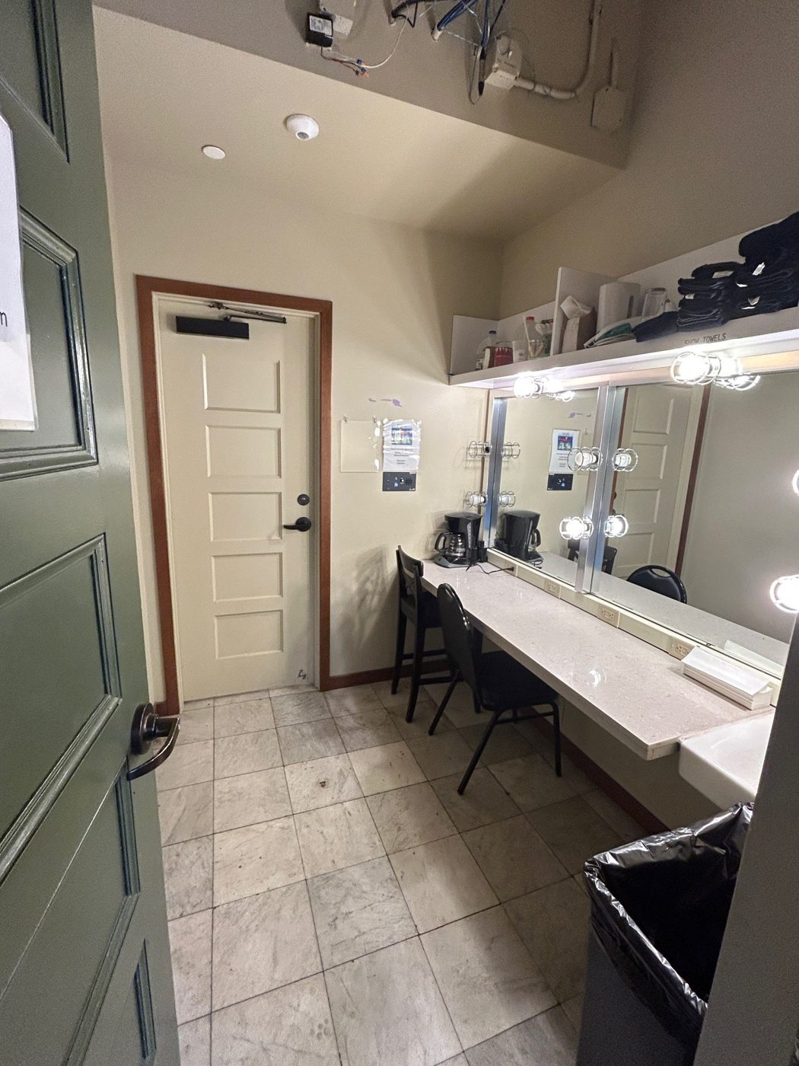  Stage-level dressing room (A and B match) | 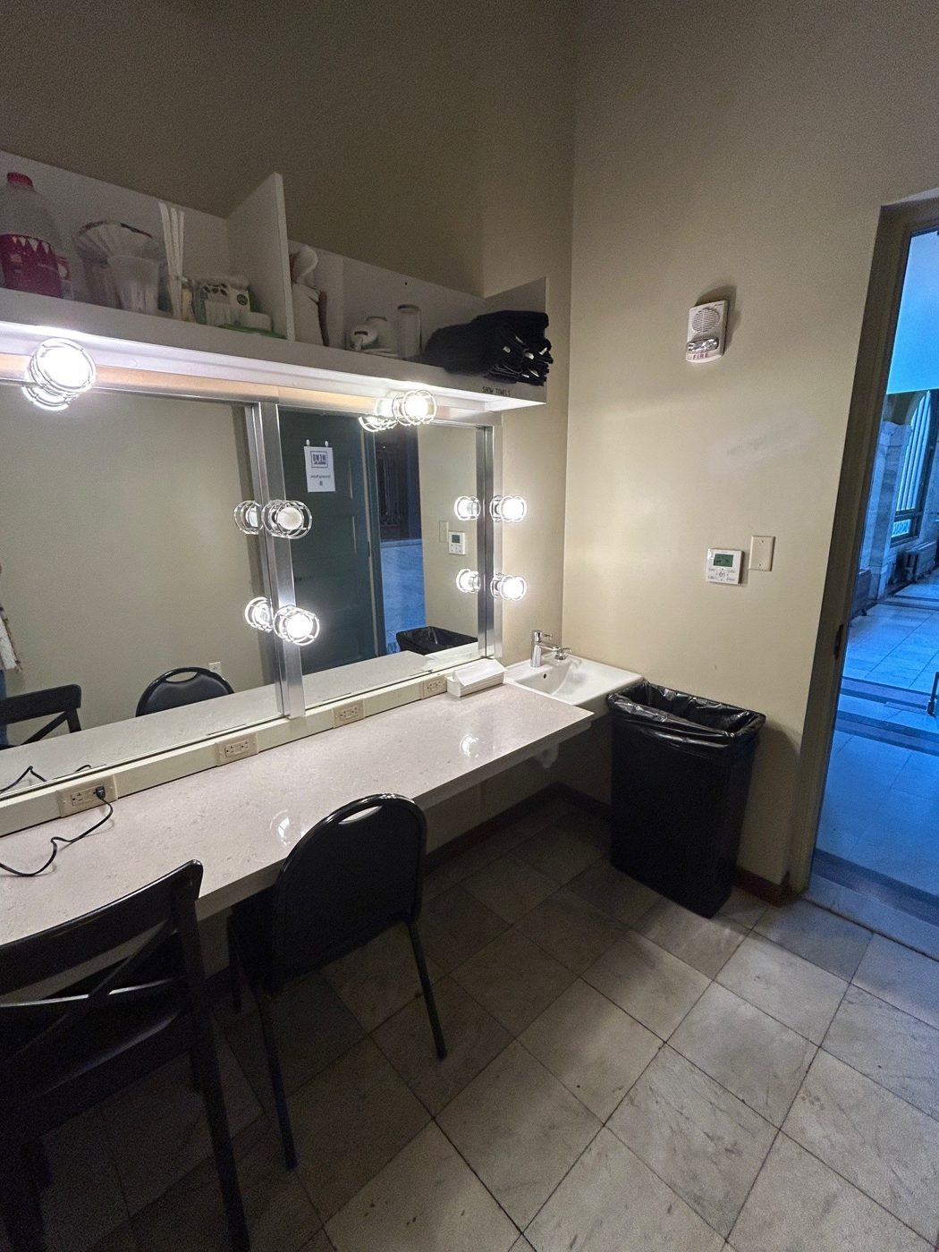  Stage-level dressing room, vanity and counter | 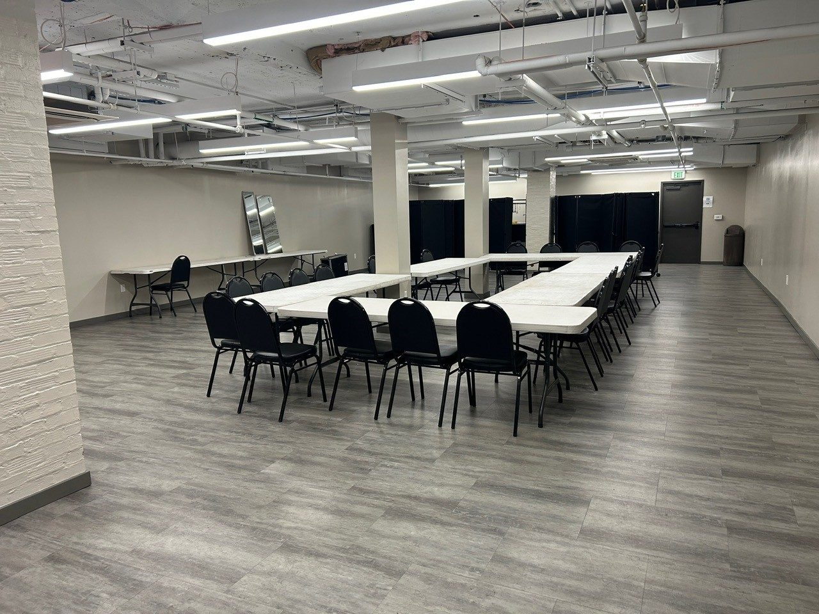  The Studio, basement level

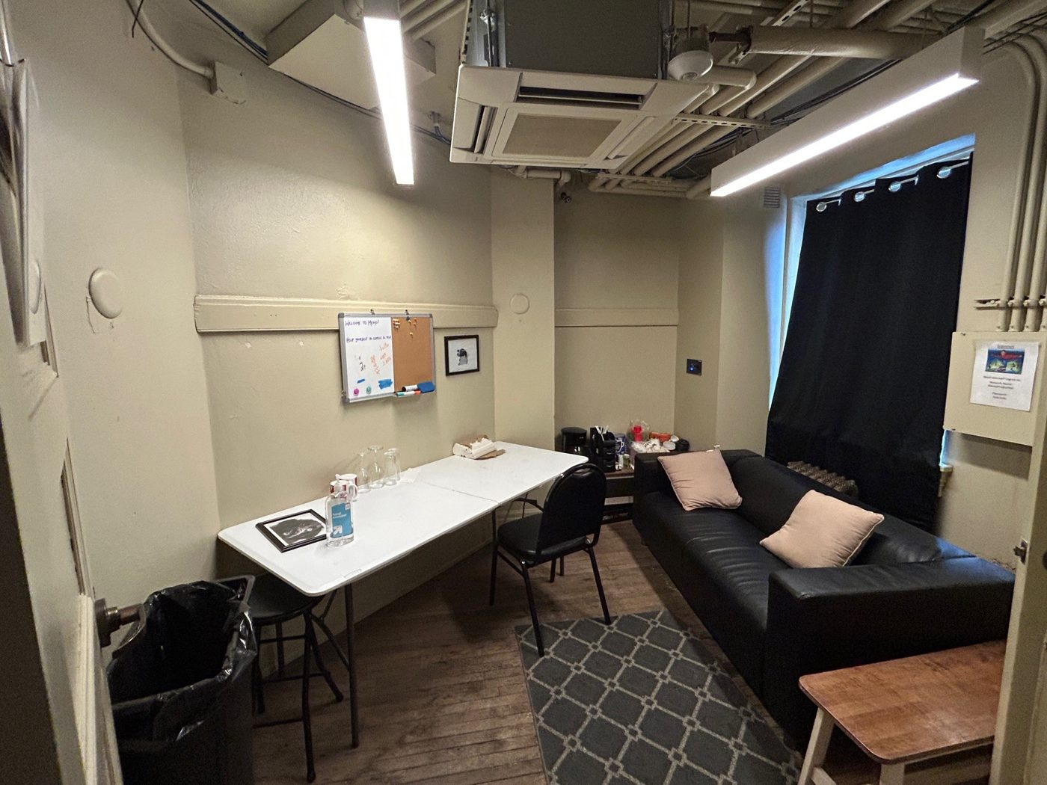  Dressing Room C, balcony level, stage right | 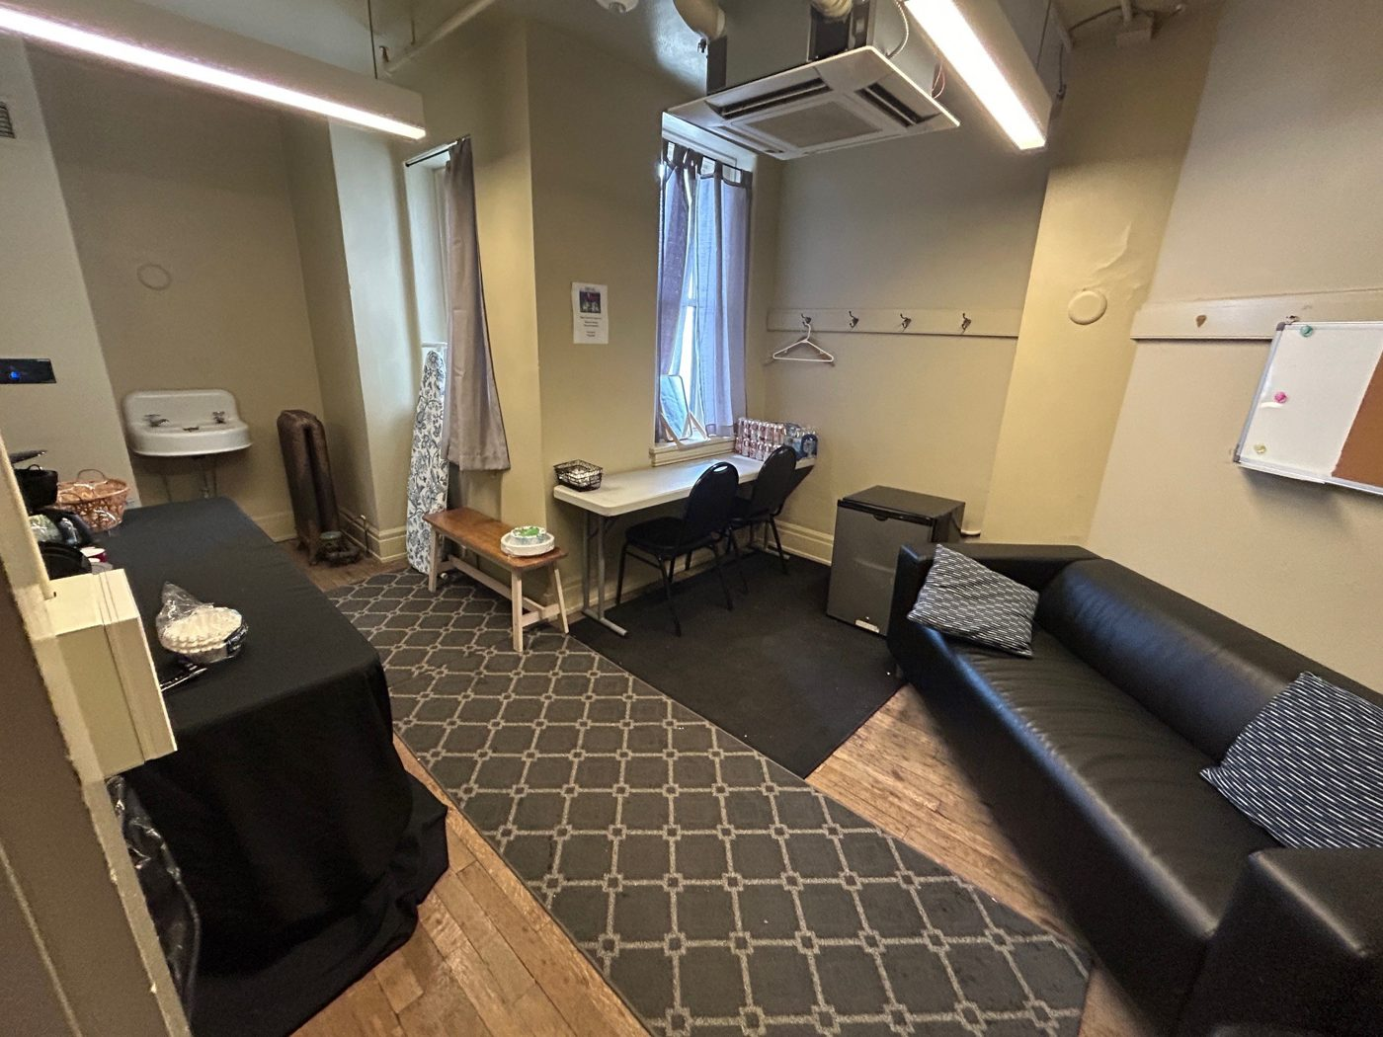  Dressing Room D, balcony level, stage left

ADDITIONAL TERMS
Building curfew | 90 minutes after the scheduled end of the show. All touring personnel, artists and gear must be out of the building by then.
Left behind | Tell us right away if you leave something behind. Anything left in the building may be thrown out.
Radius | No other shows within 90 miles of Cincinnati for 60 days before or after your date.
Merchandise | The house takes no cut of merch sales. Bring your own POS system and bank. We can help arrange a seller if you need one.
Security | We may have security on site, but you're responsible for your own gear and belongings.

